AI PROPOSAL WRITER USING n8n
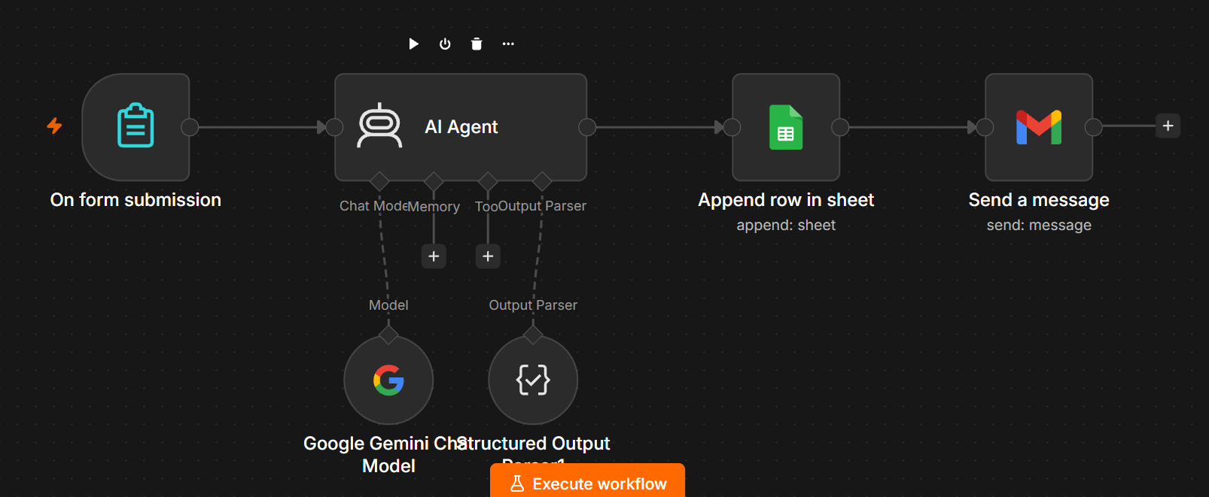

1. Project Objective
Build an AI Proposal Writer in n8n that collects project information through an On Form Submission trigger and uses an AI Agent with Google Gemini Chat Model to generate a professional business proposal. A Structured Output Parser can be added to force the AI response into a consistent structure.

2. Final Workflow
Basic version:
On Form Submission → AI Agent → Proposal Output
AI connections:
Google Gemini Chat Model → AI Agent (Chat Model)
Structured Output Parser → AI Agent (Output Parser)

3. Nodes Required
Node | Purpose | Connection
On Form Submission | Collect client/project information | Main workflow
AI Agent | Generate the proposal | Receives form data
Google Gemini Chat Model | Provides the AI model | AI Agent → Chat Model
Structured Output Parser | Enforces structured AI output | AI Agent → Output Parser

4. Step 1 — Create the Workflow
1. Open n8n.
2. Click Create Workflow.
3. Rename the workflow to: AI Proposal Writer.
4. Click Add first step.
5. Search for Form Trigger / On Form Submission.

5. Step 2 — Configure On Form Submission
Create the following form fields:
Field | Type | Name | Example
Client Name | Text | client_name | ABC Technologies
Project Name | Text | project_name | CRM Development
Project Requirements | Textarea | requirements | CRM with lead management and WhatsApp integration
Budget | Text | budget | ₹2,00,000
Timeline | Text | timeline | 30 days
Company Name | Text | company_name | ABC AI Solutions
After creating the fields, execute the form and submit test information. Confirm that the form trigger returns the entered values.

6. Step 3 — Add the AI Agent
1. Click the + after On Form Submission.
2. Search for AI Agent.
3. Add the AI Agent.
4. Connect the main output of On Form Submission to the main input of AI Agent.

7. Step 4 — Add Google Gemini Chat Model
1. In the AI Agent, locate the Chat Model connection.
2. Click the + under Chat Model.
3. Search for Google Gemini Chat Model.
4. Select or create your Gemini credential.
5. Select an available Gemini model.
6. Confirm that the green/dashed Chat Model connection goes from Google Gemini Chat Model to the AI Agent's Chat Model port.

8. Step 5 — Configure the AI Agent Prompt
Use this prompt in the AI Agent user-message/prompt field:
Create a professional business proposal using the client information below.
CLIENT NAME:
{{ $json.client_name }}
PROJECT NAME:
{{ $json.project_name }}
OUR COMPANY:
{{ $json.company_name }}
PROJECT REQUIREMENTS:
{{ $json.requirements }}
BUDGET:
{{ $json.budget }}
TIMELINE:
{{ $json.timeline }}
Create a complete professional proposal containing:
1. Proposal Title
2. Client Name
3. Project Name
4. Executive Summary
5. Understanding of Requirements
6. Proposed Solution
7. Key Features
8. Project Scope
9. Deliverables
10. Technology / Implementation Approach
11. Project Timeline
12. Pricing
13. Assumptions
14. Next Steps
15. Conclusion
Rules:
- Use professional business language.
- Do not invent requirements.
- Keep the provided budget and timeline unchanged.
- Clearly label assumptions.
- If information is missing, state that it is missing instead of inventing it.
- Make the proposal client-ready and easy to read.

9. Step 6 — AI Agent System Message
You are an expert B2B proposal writer.
Create accurate, professional and persuasive business proposals from the information supplied by the user.
Rules:
1. Never fabricate client requirements.
2. Never promise guaranteed results.
3. Separate confirmed information from assumptions.
4. Use clear headings and bullet points.
5. Keep pricing exactly as provided.
6. Keep the timeline exactly as provided.
7. If information is missing, identify it as missing or an assumption.
8. Do not mention that you are an AI.
9. Return only the proposal content.

10. Step 7 — Add Structured Output Parser
The Structured Output Parser is optional for the first working version, but recommended when you want consistent fields for later steps such as Google Docs, PDF generation, email, CRM storage, or databases.
Important: In the current AI Agent configuration, first enable the option that requires a specific output format (wording can vary by n8n version). This exposes/enables the Output Parser connection on the AI Agent.
Then add Structured Output Parser and connect it to the AI Agent's Output Parser connection. Do NOT connect it to Chat Model, Memory, or Tool.

11. Structured Output Schema
{
"proposal_title": "string",
"client_name": "string",
"project_name": "string",
"executive_summary": "string",
"requirements": "string",
"proposed_solution": "string",
"key_features": ["string"],
"deliverables": ["string"],
"technology": "string",
"timeline": "string",
"pricing": "string",
"assumptions": ["string"],
"next_steps": ["string"],
"conclusion": "string"
}

12. Correct Connection Layout
Main workflow:
On Form Submission → AI Agent
AI connections:
Google Gemini Chat Model → AI Agent [Chat Model]
Structured Output Parser → AI Agent [Output Parser]
Leave Memory and Tool empty for this beginner version.

13. If the Output Parser Cannot Be Connected
- Open the AI Agent node.
- Check its Parameters/settings.
- Find the option related to requiring a specific output format.
- Enable it.
- Return to the canvas and check the AI Agent connection ports.
- Connect Structured Output Parser to the newly available Output Parser port.
- Do not drag the parser to the Tool or Chat Model port.

14. Step 8 — Test the Workflow
Use test data such as:
Client Name: ABC Technologies
Project Name: CRM Development
Project Requirements: CRM with lead management, customer management,
WhatsApp integration, automated follow-ups and reporting dashboard.
Budget: ₹2,00,000
Timeline: 30 days
Company Name: ABC AI Solutions
Execute the workflow and verify that the AI generates a proposal. If you are not using the parser yet, the result can appear as one output field. That is normal for the basic version.

15. Expected Proposal Sections
- Proposal Title
- Prepared For / Client
- Executive Summary
- Understanding of Requirements
- Proposed Solution
- Key Features
- Project Scope
- Deliverables
- Technology / Implementation Approach
- Timeline
- Pricing
- Assumptions
- Next Steps
- Conclusion

16. Recommended Next Version
After the AI proposal is working correctly, extend the workflow to create a document, generate a PDF, and email it to the client.
Recommended flow:
On Form Submission → AI Agent → Structured Output Parser → Google Docs → PDF → Gmail

17. Common Mistakes
Mistake | Fix
Connecting Structured Output Parser to Tool | Incorrect. Connect it to Output Parser.
Connecting Gemini directly to the main workflow | Gemini should connect to the AI Agent Chat Model port.
Adding Memory immediately | Not required for a single proposal generation workflow.
Using a vague prompt | Specify required sections and rules.
Letting AI invent budget/timeline | Tell the AI to preserve supplied values.
Adding PDF/email before testing AI output | First make the AI proposal work, then extend the workflow.

18. Final Checklist
☐ On Form Submission created
☐ All proposal form fields created
☐ Form successfully tested
☐ AI Agent added
☐ Google Gemini Chat Model connected to Chat Model
☐ Proposal prompt added
☐ System message added
☐ Specific output format enabled when using parser
☐ Structured Output Parser added
☐ Parser connected to Output Parser port
☐ Workflow tested with sample client data
☐ Proposal output checked for accuracy

19. Beginner Build Order
Build only the first four parts initially:
1. On Form Submission
2. AI Agent
3. Google Gemini Chat Model
4. Test the proposal
Then add Structured Output Parser. After that, add Google Docs, PDF and Gmail.

